EXERCISE 4.1

**NCERT Solutions for Class 10 Chapter 4-**

**Quadratic Equations**

EXAMBUDDY

Question 1:

Check whether the following are quadratic equations:

(i) (x+ 1)2=2(x-3)  
(ii) x – 2x = (- 2) (3-x)  
(iii) (x – 2) (x + 1) = (x – 1) (x + 3)  
(iv) (x – 3) (2x + 1) = x (x + 5)  
(v) (2x – 1) (x – 3) = (x + 5) (x – 1)  
(vi) x2 + 3x + 1 = (x – 2)2  
(vii) (x + 2)3 = 2x(x2 – 1)  
(viii) x3 -4x2 -x + 1 = (x-2)3

**Solution:**

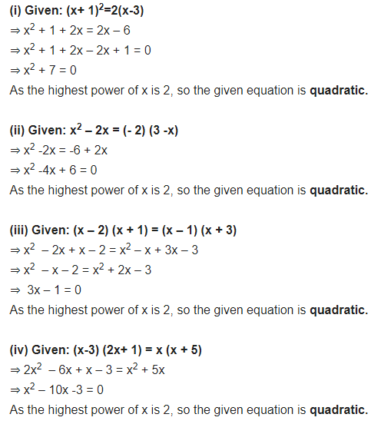

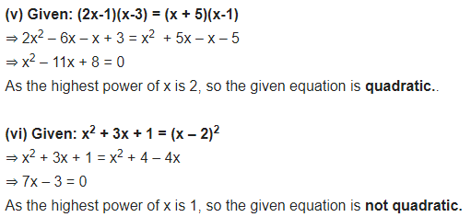

Question 2:

Represent the following situations in the form of quadratic equations:

1. The area of a rectangular plot is 528 m2. The length of the plot (in metres) is one more than twice its breadth. We need to find the length and breadth of the plot.

Solution:

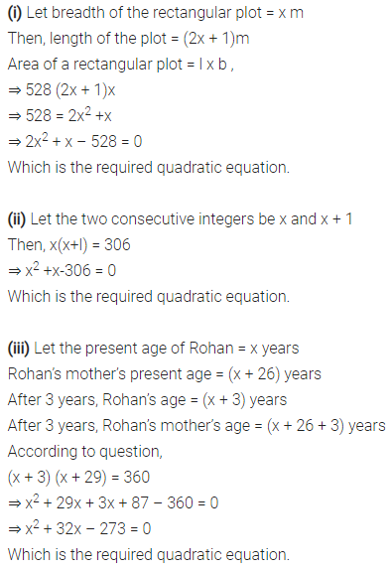

1. The product of two consecutive positive integers is 306. We need to find the integers.

Solution:



1. Rohan’s mother is 26 years older than him. The product of their ages (in years) 3 years from now will be 360. We would like to find Rohan’s present age.

Solution:



1. A train travels a distance of 480 km at a uniform speed. If the speed had been 8 km/h less, then it would have taken 3 hours more to cover the same distance. We need to find the speed of the train.

Solution:

